
2.4
Written Task: Magazine layouts
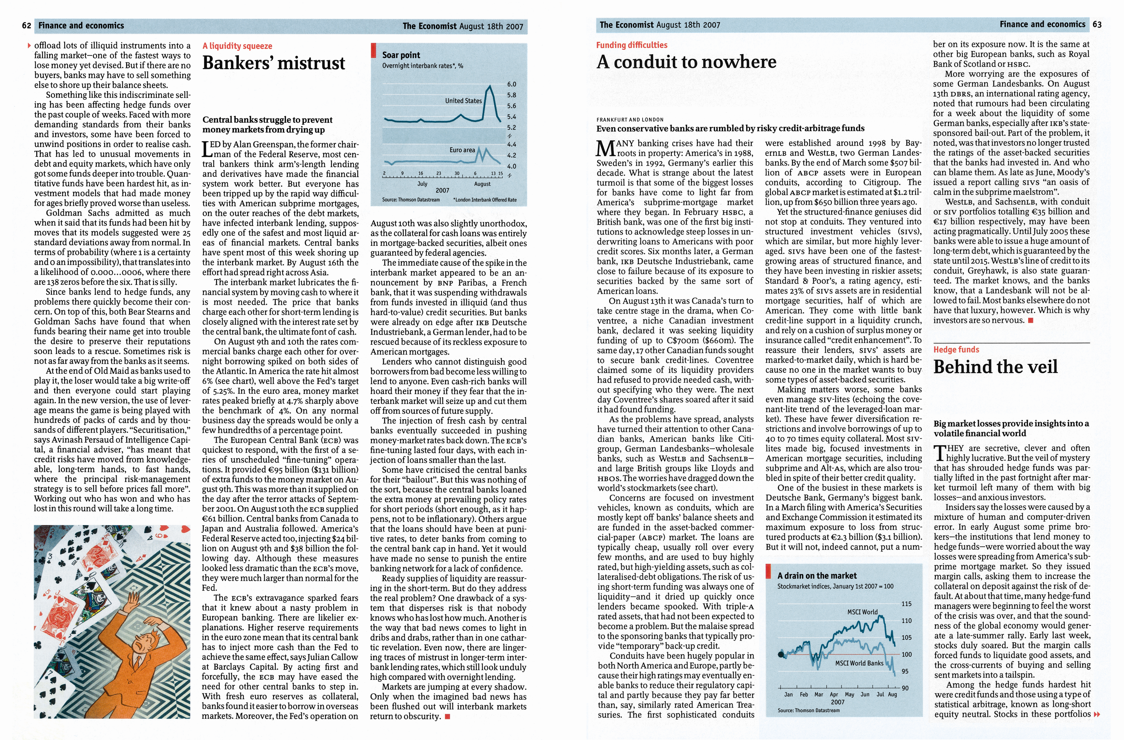
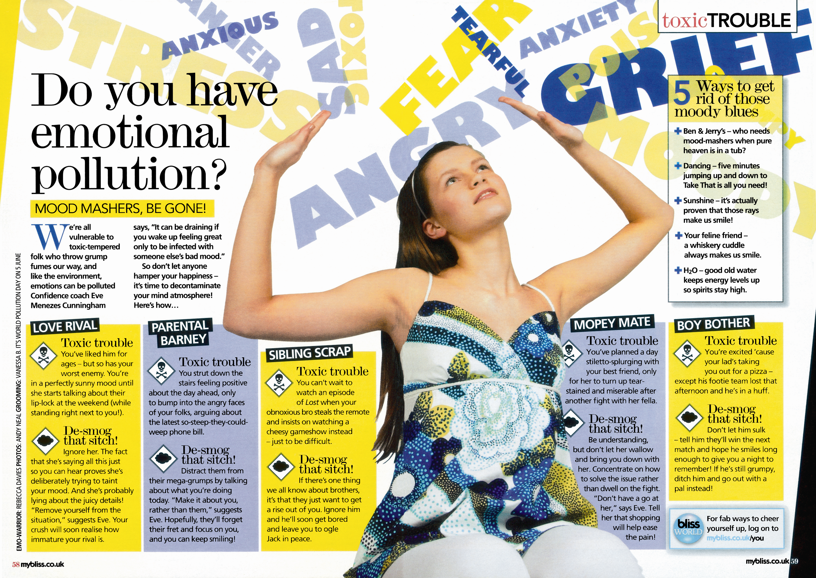

Figure 1 Page from The Economist Figure 2 Page from Bliss magazine
Look at these two pages. One is from a magazine for teenagers and one is from a business magazine. Both have been designed using desktop publishing (DTP) software.
Explain all of the differences that you can see between the two.

