3 Modelling

Student’s ICT Workbook

Name:

Year 8

Subject: ICT

IMPORTANT NOTE:

1. Students must always bring this ICT Workbook and ICT InteraCT for KS3 textbook during any ICT lessons.

2. Students are required to complete all given tasks on time.

3. Students are required to study the Skills Tutorials and must
practice on their own to understand the topic.

ICT InteraCT for KS3 2 © Hodder Education 2008

Page 1 of 40
3.1

Written Task: Identifying variables

Your task is to identify what variables you would need to use in a spreadsheet model, if you were trying to solve these problems. The first one has been done for you.

1 A clothes shop wants to predict the total amount of money it will make from selling clothes.

Variables needed:
> The items they sell, e.g. Jeans, tops, etc.
> The price of each item
> The number of each item sold

2 A student wants to predict the total cost of running a car for a year.

3 A concert hall wants to predict how much profit it will make putting on a pop concert.

4 A school wants to predict what grades pupils will get in their English, Maths and
Science SATs exams.

5 NASA wants to predict how much fuel they need to send a rocket to Mars.

ICT InteraCT for KS3 2 © Hodder Education 2008

Page 2 of 40
3.1 (L4 – 5) ●

End of Unit Activity: Setting up a model

In this task you need to:

> Create a spreadsheet model
> Set up the variables in a spreadsheet model
> Set up the rules in a spreadsheet model

A large concert hall has seating for 3000 people. The managers want to know how quickly they could get everyone out of the hall if there was a fire.

They know that they can evacuate 100 people per minute out of each fire exit. At the moment, they have three fire exits in the hall.

Your task is to develop the ‘Concert Hall Evacuation Model’ and then answer the following questions.

1 How many minutes would it take to evacuate the hall if there were 3000 people in it?

2 How many minutes would it take to evacuate the hall if there were 2000 people in it?

3 They are thinking about building an extra fire exit. How many minutes would it take to evacuate the hall of 3000 people with this extra fire exit?

4 Their health and safety officer tells them that they need to be able to evacuate
3000 people in 3 minutes. How many fire exits do they need?

ICT InteraCT for KS3 2 © Hodder Education 2008

Page 3 of 40
3.1 (L5 – 6) ▲

End of Unit Activity: Setting up a model

In this task you need to:

> Create a spreadsheet model
> Set up the variables in a spreadsheet model
> Set up the rules in a spreadsheet model

A large concert hall has seating for 3000 people. The managers want to know how quickly they could get everyone out of the hall if there was a fire.

They know that they can evacuate 100 people per minute out of each fire exit. At the moment, they have three fire exits in the hall.

Your task is to develop the ‘Concert Hall Evacuation Model’ and then answer the following questions.

1 How many minutes would it take to evacuate the hall if there were 3000 people in it?

2 How many minutes would it take to evacuate the hall if there were 2000 people in it?

3 They are thinking about building an extra fire exit. How many minutes would it take to evacuate the hall of 3000 people with this extra fire exit?

4 Their health and safety officer tells them that they need to be able to evacuate
3000 people in 3 minutes. How many fire exits do they need?

5 How accurate do you think your model is? What other variables could you build in to make it more realistic?

ICT InteraCT for KS3 2 © Hodder Education 2008

Page 4 of 40
3.2 OFFICE 2007


SKILLS TUTORIAL 1

This tutorial will show you how to add drop down lists to a cell in Excel.

• Open Excel.
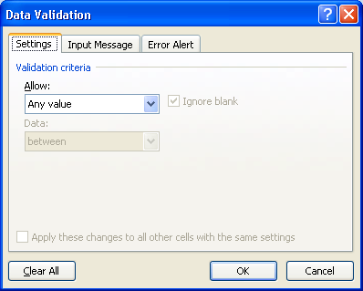

• Click in cell A2 and type: Options.
• Click in cell B2.
• Click on ‘Data’ on the menu options.
• Select ‘Data Validation’.
This screen is then displayed. Normally, people can type
whatever they want into a cell
of a spreadsheet. Using validation restricts what people can type in. In this case, we are going to give the user a list of options to choose from.

• Click on the drop down list where it says ‘Allow’. It is currently set to ‘Any value’.
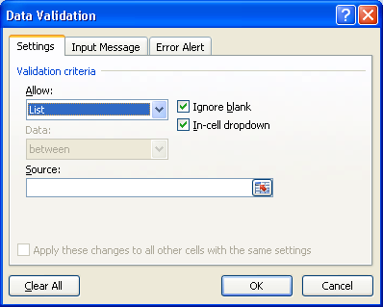

• Select ‘List’.

In the box where it says ‘Source’ you can now type in what you want in the drop down list.

1 of 2

ICT InteraCT for KS3 2 © Hodder Education 2008

Page 5 of 40
You need to put a comma in between each item on the list, e.g.

• Type ‘Option 1,Option
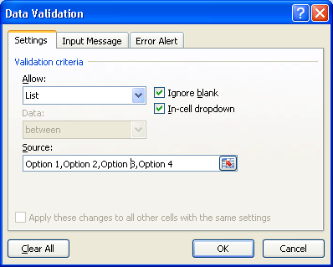

2,Option 3,Option 4’ as shown
• Click ‘OK’.

If you now click on the drop down arrow in cell B2, the list of options will be displayed in the drop down list.

2 of 2

ICT InteraCT for KS3 2 © Hodder Education 2008

Page 6 of 40
3.2

Written Task: Checking a model

Your task is to review the Mobile Phone model that we used in the last unit. Look at the model below and then answer the questions:

Figure 1 Spreadsheet used to check phone costs

1 How accurate do you think the model is? Explain your answer.

2 How realistic do you think the model is? Explain your answer.

3 Describe what changes you would make to the model to make it more realistic.

ICT InteraCT for KS3 2 © Hodder Education 2008

Page 7 of 40
3.2 OFFICE 2007



SKILLS TUTORIAL 2

This tutorial will show you how to write an ‘If statement’.

• Open Excel

• Click in cell A2 and set up a drop down list with two items in it – Price 1 and Price 2, as shown here
• Click in cell B2.

• Type the following formula: =IF(A2=“Price 1”,100,50).

This means that if the value in cell A2 is set to Price 1, then the value in cell B2 will be 100.

If the value in A2 is set to Price 2, then the value in cell B2 would be 50.

You can use If statements on any value – it does not have to be from values in a drop down list.

1 of 2

ICT InteraCT for KS3 2 © Hodder Education 2008

Page 8 of 40
3.2 (L4 – 5) ●

End of Unit Activity: Developing the mobile phone model

In this activity you need to:

> Develop a model to make it more accurate
> Develop a model to make it more realistic
> Use added drop-down lists
> Use If statements

1 Your task is to take the ‘Mobile Phone model’ and to develop it to make it more accurate and realistic. You should try to include the suggestions you made in the earlier written task.

You may think that it is better to start the model from scratch.

2 When you have finished, ask someone to review your model using a Peer
Review sheet. You should also review their model.

3 Make any final changes that you think are necessary after the review.

ICT InteraCT for KS3 2 © Hodder Education 2008

Page 9 of 40
3.2 (L5 – 6) ▲

End of Unit Activity: Developing the mobile phone model

In this activity you need to:

> Develop a model to make it more accurate
> Develop a model to make it more realistic
> Use added drop-down lists
> Use If statements

1 Your task is to develop a more accurate and realistic model to compare the cost of mobile phones. You should try to include the suggestions you made in the earlier written task.

2 When you have finished, ask someone to review your model using a Peer
Review sheet. You should also review their model.

3 Make any final changes that you think are necessary after the review.

ICT InteraCT for KS3 2 © Hodder Education 2008

Page 10 of 40
3.3

Written Task: Setting up data

This exercise can be completed as a Practical Task or a Written Task. The following data are recorded as part of a science experiment.
Pupils filled two containers with boiling water. One container was insulated and the other was not. They wanted to compare how quickly the temperature changed in the two containers. They recorded the temperature in each container every 30 seconds. They took ten readings.

The results (in Celsius) were:

Container 1: 100, 97, 95, 93, 91, 89, 88, 86, 84, 82

Container 2: 100, 97, 96, 95, 94, 93, 92, 91, 90, 89

 Task 1
Draw a diagram to show how you could set up these data as a table in a spreadsheet so that they could be graphed.

 Task 2
Draw a rough design of the graph(s) you would produce to show these results.

ICT InteraCT for KS3 2 © Hodder Education 2008

Page 11 of 40
3.3 OFFICE 2007

SKILLS TUTORIAL 1

This tutorial will show you how to create the table and graph used in the
Concert Hall model.

The Concert Hall Extended Model.xls file is also available so you can see how it should look when it is complete.

• Open Excel

• Type in the table of data as it appears here.

You now need to set up a formula to calculate the values in column C.

• Click in cell C5
• Type =B5*$C$2.

The dollar sign ($) creates what is called an absolute cell reference. This means that when you copy the formula to other cells, it will not change from being C2.

• Now copy the formula from cell C5 down to C14.

If you look in any of the cells, e.g. C6, you can see that B5 in the formula has changed to B6 (a relative cell reference) but that C2 has stayed the same.

We are now ready to plot the data. We need to plot column A and column C. There are two problems. The first is that column A contains numbers, which we want to plot as labels. The second problem is that the two columns are not next to each other – but we will need to highlight both so that we can plot them.

1 of 2

ICT InteraCT for KS3 2 © Hodder Education 2008

Page 12 of 40
To make sure that Excel treats the numbers in Column A as text labels:

• In cell A5: type ‘1 instead of 1 (that is, you type an inverted comma first)

This makes sure that it is treated as text and not a number.

• Do this all the way down:
‘2 in A6, ‘3 in A7 and so on, down to 10.

▼ To highlight the data we want to plot:

• Drag the mouse over rows A4 to A14 as shown here.

2 of 2

ICT InteraCT for KS3 2 © Hodder Education 2008

Page 13 of 40
• Now hold down the CTRL key and highlight cells C4 to C14 as shown here

Both columns are now highlighted. Using the CTRL key lets you highlight cells that are not next to each other.

• Now click insert

• Click the column icon in the charts section.

You can use the chart wizard options to plot a graph. You were shown how to do this in Skills Tutorial 3.7 in Year 7. If you can’t remember how to do it, you
should work through this tutorial again.

When your graph is complete you will find that if you change any of the values in the cells that you have plotted, the graph will update automatically to show those changes.

3 of 2

ICT InteraCT for KS3 2 © Hodder Education 2008

Page 14 of 40
3.3 (L4 – 5) ●

End of Unit Activity: Graphing data

In this activity you need to:

> Use graphs to answer ‘what if’ type questions
> Set up data for plotting
> Select the data to plot

Your task is to create suitable graphs using the ‘10km Running times’ model. This shows how long it takes three different runners to run a 10km (6 miles) race. Their times are recorded for each kilometre.

1 Create a graph or graphs to show the times at each 1km interval for all three runners. Copy and paste your graph here.

1 of 2

ICT InteraCT for KS3 2 © Hodder Education 2008

Page 15 of 40
2 Create a graph or graphs that will show the total time for the 10km race for each runner. Copy and paste your graph here.

Now use the graphs to answer the following questions:

3 Which runner is fastest over 10km?

4 Which runner has the fastest time for any single kilometre?

5 Who is the most consistent runner? That is, they have the smallest variation in how long it takes them to run each kilometre?

6 Who do you think might win a 5km race based on these times?

2 of 2

ICT InteraCT for KS3 2 © Hodder Education 2008

Page 16 of 40
3.3 (L5 – 6) ▲

End of Unit Activity: Graphing data

Your task is to create suitable graphs using the ‘10km Running times’ model. This shows how long it takes three different runners to run a 10km (6 miles) race. Their times are recorded for each kilometre.

Your task is to create a suitable graph or graphs and use them to answer the following questions. Copy and paste your graphs at the end of this document.

Now use the graphs to answer the following questions:

1 Which runner is fastest over 10km?

2 Which runner has the fastest time for any single kilometre?

3 Who is the most consistent runner? That is, they have the smallest variation in how long it takes them to run each kilometre?

4 Who do you think might win a 5km race based on these times?

ICT InteraCT for KS3 2 © Hodder Education 2008

Page 17 of 40
3.4

Written Task: Variables and rules

A variable is a factor that computer games have to take into account so that they are like real life. For example, in a flight simulator, they have to include weather conditions and what type of plane it is.

A rule is how the game decides what will happen depending on what instructions it gets from the player. For example, in a flight simulator, if the player pushes the accelerator, the plane must go faster.

Your task is to identify the variables and rules that might be used in the following computer games.

1 Formula 1 Racing Game

This game lets you build and then race your Formula 1 car. The objective is to win as many races as possible.

Variables

Rules

1 of 2

ICT InteraCT for KS3 2 © Hodder Education 2008

Page 18 of 40
2 Raise your own Pet

This game lets you buy and look after your own pet. The objective is to win awards in pet shows.

Variables

Rules

2 of 2

ICT InteraCT for KS3 2 © Hodder Education 2008

Page 19 of 40
3.4 OFFICE 2007

SKILLS TUTORIAL 1

In this tutorial you will learn how to use the Investment Manager simulation that has been created in Excel.

• Open Investment Manager.xls if it is not already open. The model is made up of two different worksheets.

You can flick between the two worksheets using the tabs at the bottom of the screen as shown here.

The ‘Set up Investments’ worksheet is where you can decide how you want to invest your £10,000. The purpose of the model is to try and make as much money as possible from your investments.

• Fill in the yellow cells, putting in the amount you want to spend on each option.

For example, you could put all
£10,000 in a Savings Account, or you could split your money equally across all four options.

1 of 3

ICT InteraCT for KS3 2 © Hodder Education 2008

Page 20 of 40

When you have finished, make sure that the total value in cell B12 is not above £10,000. If it is it will go red. You will have to change the values to make sure this is £10,000 or less.

• Now click on the Results tab.

This example is the result with £2,500 in each of the four options.

To understand these results:

• Look in column B for Year 1.

It shows how much money it has predicted you will make from each of your investments. For example, the Savings Account is now worth £2572.64 (cell B5), which is slightly up on the £2500 you put in. The Stock Market however is worth
£3153.75 (cell B7), which means you have made over £600.

2 of 3

ICT InteraCT for KS3 2 © Hodder Education 2008

Page 21 of 40
The New Total value in B10 shows you how much your £10,000 is worth at the end of Year 1. In this case, you have lost £1296.98 (shown in B12).

The values are then calculated for the 5-year period, showing you how much your investments are worth at the end of each year.

The value in B18 shows you how much money you have made or lost in total. In this case, you would have lost £4408.82 over 5 years from your original £10,000.

The red cells mean a loss and the green cells mean a gain. In this example, there were no overall gains during any of the five years.

Remember that this is a simulation of real life – it is not necessarily what would
happen.

• Press F9.

All of the values will now recalculate. Pressing F9 asks the model to make another prediction of what might happen based on the way you set up your options. You can keep clicking F9 to get different predictions of what might happen.

You can now go back and change the way your money is invested. For example, you might find that if you gamble all the time, the chances are that you will lose most of your money. In this case, you will want to change the setting:

• Click on the Set up Investments tab and reset the values to whatever you want them to be.
• Click on the Results and see what effect this has.

You can use the model as many times as you like to simulate what could happen in real life.

3 of 3

ICT InteraCT for KS3 2 © Hodder Education 2008

Page 22 of 40
3.4 (L4 – 5) ●

End of Unit Activity: Understanding Investment
Manager

In this activity you need to:

> Use a simulation to predict what will happen in real life
> Understand the rules of a simulation

You will need to experiment with the Investment Manager spreadsheet before you answer these questions.

Remember that the objective of Investment Manager is to make as much money as possible over five years.

1 Which of the four options is likely to make you the most money over five years?

2 Which of the four options is likely to lose you the most money over five years?

3 If you had £10,000 to invest, how would you split it across the four options and why?

4 What is the most money you have made playing Investment Manager? Copy and paste your best ever result here. What did you set as the options to get this result?

5 What is the most money you have lost playing Investment Manager? Copy and paste your worst ever result here. What did you set as the options to get this result?

ICT InteraCT for KS3 2 © Hodder Education 2008

Page 23 of 40
3.4 (L5 – 6) ▲

End of Unit Activity: Understanding Investment
Manager

In this activity you need to:

> Use a simulation to predict what will happen in real life
> Understand the rules of a simulation

You will need to experiment with the Investment Manager spreadsheet before you answer these questions.

Remember that the objective of Investment Manager is to make as much money as possible over five years.

1 Which of the four options is likely to make you the most money over five years?

2 Which of the four options is likely to lose you the most money over five years?

3 If you had £10,000 to invest, how would you split it across the four options and why?

4 What is the most money you have made playing Investment Manager? Copy and paste your best ever result here. What did you set as the options to get this result?

5 What is the most money you have lost playing Investment Manager? Copy and paste your worst ever result here. What did you set as the options to get this result?

6 Describe what calculations you think the model is using to predict the results.

7 Do you think the model is realistic? If not, what other factors would you add to it?

ICT InteraCT for KS3 2 © Hodder Education 2008

Page 24 of 40
3.5 OFFICE 2007

SKILLS TUTORIAL 1

This tutorial will show you how to use the RANDBETWEEN function. It will work through how to create the Dice Game model.

• Open Excel.

• In cell A1, type: The
Dice Game.
• In cell A3, type: Die 1.
• In cell A4, type: Die 2.
• In cell A6, type: Total.

• In cell B3 type: =RANDBETWEEN(1,6)

This will generate a random number between 1 and 6

• Do the same or copy the formula into cell B4.

This adds up the result of the two dice.

• Save the file as: ‘The Dice Game’.
You will notice to start with that it will show the same number.

• Press F9

F9 re-does the calculation. In this case, pressing F9 is like rolling the dice.

• In cell B6, type:
=SUM(B3:B4)

1 of 1

ICT InteraCT for KS3 2 © Hodder Education 2008

Page 25 of 40

3.5

Written Task: Random numbers

 Question 1
The National Lottery main draw uses
balls numbered 1 to 49. They are drawn  at random.

A spreadsheet is used to simulate the draw of the six balls and the bonus ball. This formula is used: RANDBETWEEN (0-49).

Figure 1 Balls drawn in the National Lottery

The simulation is then run:

a The first number the simulation comes up with is 49. Is this realistic?

b The next number the simulation comes up with is 0. Is this realistic?

c The next number the simulation comes up with is 49 again. Is this realistic?

1 of 3

ICT InteraCT for KS3 2 © Hodder Education 2008

Page 26 of 40
d There is an equal chance of getting any number from 1 to 49. Is this realistic?

 Question 2

A standard dartboard has the numbers 1–20.

The bullseye is worth 50 and the ring around the bullseye is worth 25.

You can also score doubles and trebles of any of the numbers from 1–20.

A spreadsheet is used to simulate the score that someone might get throwing one dart.

This formula is used: RANDBETWEEN (1-60).

Figure 2 Figure 3 Scoring at darts

The simulation is then run:

a The first number the simulation comes up with is 20. Is this realistic?

b The next number the simulation comes up with is 23? Is this realistic?

c Sometimes a player misses the board completely. How could you change the formula to take account of this?

2 of 3

ICT InteraCT for KS3 2 © Hodder Education 2008

Page 27 of 40
d There is an equal chance of getting any of the numbers from 1 to 60. Is this realistic?

3 of 3

ICT InteraCT for KS3 2 © Hodder Education 2008

Page 28 of 40
3.5 OFFICE 2007

SKILLS TUTORIAL 2

This tutorial will show you how to add conditional formatting to a cell.

• Open ‘The Dice Game’ file if it is not open already.

We are going to set up some conditional formatting so that if a 7 or 11 are thrown, the cell showing the total will go green to show you that you have won.

• Click in cell B6.

• From the Home tab, select ‘Conditional
Formatting’.
• Click ‘New rule’.

This screen is now displayed.

• Click ‘Format only cells that contain’.

• Select the drop down that reads
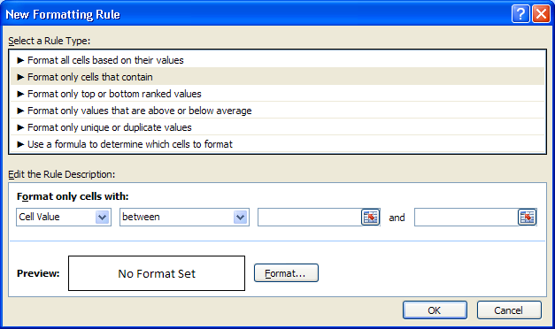

‘between’ and change it to ‘equal to’.
• In the next box, type 7.
• Then click on
‘Format’.

1 of 2

ICT InteraCT for KS3 2 © Hodder Education 2008

Page 29 of 40

This window is displayed:

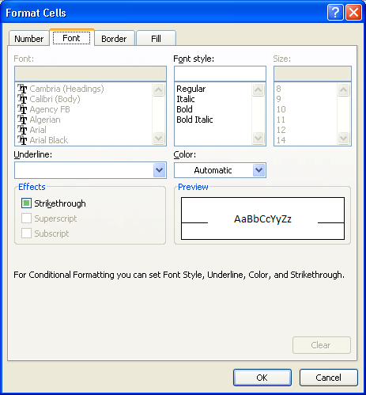

The screen should now look like this:
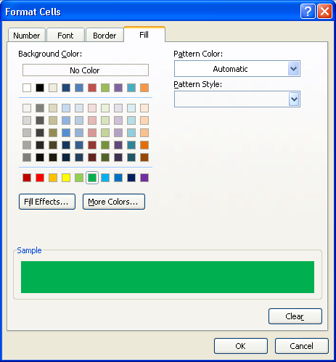

• Select ‘Fill’.
• Under ‘background colour’, select green from the colour palette.

• Click OK.
• Now do the same for the number 11.

If cell B6 is either 7 or 11, it will make the cell colour green. If not, it will stay white.

2 of 2

ICT InteraCT for KS3 2 © Hodder Education 2008

Page 30 of 40

3.5 OFFICE 2007

SKILLS TUTORIAL 3

This tutorial will show you how to create an ‘If statement’.

• Open ‘The Dice Game’ file if it is not already open.
• Click in cell C6.

We are going to set up a label that tells the player whether they have won or not. If they have won it will say ‘Congratulations’. If they have lost, it will say: ‘Better luck next time’.

The player wins if they get either a 7 or an 11, so we will have to set up an If statement with both numbers in it.

• Type: =IF(B6=7,"Congratulations",IF(B6=11,"Congratulations","Better luck next time"))

This is how the formula works:

The basic layout is: =IF(Condition, True, False)

In other words, after IF and the opening bracket, you put the condition, in this case whether B6 = 7.

Then, after the comma, you tell it what to do if the condition is true i.e. if B7 is equal to 7.

Then, after the next comma, you tell it what to do if the condition is false i.e. if B7 is not equal to 7.

This formula is a bit more complicated because we are checking for two conditions.
1 of 2

ICT InteraCT for KS3 2 © Hodder Education 2008

Page 31 of 40
• If the value in cell B6 is equal to 7, then the word Congratulations is shown in cell C7.
• If the value in cell B6 is equal to 11, then the word Congratulations is shown in cell C7.
• If neither of those are true (i.e. the number is anything other than 7 or 11), then the words Better luck next time are shown in cell C7.

This is called a nested If statement, because there is one ‘if statement’ inside another ‘if statement’.

These can be quite complicated:

You have to put the commas in the right place.

Every time you open a set of brackets you close them at the end of the formula. That is why this formula has two closing brackets.

2 of 2

ICT InteraCT for KS3 2 © Hodder Education 2008

Page 32 of 40
3.5 (L4 – 5) ●

End of Unit Activity: Card game simulation

In this activity you need to:

> Create a simulation
> Use random numbers
> Use conditional formatting
> Use If statements

Your task is to create a card game based on the game Blackjack (also known as twenty ones). The basic layout is provided in the ‘Card game simulation’ file. Notice that there are two worksheets used – one for Player 1 and one for the Dealer.

The rules are:

> Player 1 is dealt three cards.
> Each card has a value of between 1 and 11.
> The value of the three cards is added up.
> If the value is greater than 21 then Player 1 is bust and the Dealer wins.

If the value is 21 or less:

> The Dealer is dealt three cards.
> Each card has a value of between 1 and 11.
> The value of the three cards is added up.
> If the value is greater than 21 then the Dealer is bust and Player 1 wins.

If neither Player 1 nor the Dealer is bust:

> Whoever has the highest number wins.
> If they have the same value, the Dealer wins.

Your task

Complete the Card game simulation model and add any conditional formatting or If statements to make it clear who has won each time the simulation is run.

ICT InteraCT for KS3 2 © Hodder Education 2008

Page 33 of 40
3.5 (L5 – 6) ▲

End of Unit Activity: Card game simulation

In this activity you need to:

> Create a simulation
> Use random numbers
> Use conditional formatting
> Use If statements

Your task is to create a card game based on the game Blackjack (also known as twenty ones). The basic layout is provided in the ‘Card game simulation’ file. Notice that there are two worksheets used – one for Player 1 and one for the Dealer.

The rules are:

> Player 1 is dealt three cards.
> Each card has a value of between 1 and 11.
> The value of the three cards is added up.
> If the value is greater than 21 then Player 1 is bust and the Dealer wins.

If the value is 21 or less:

> The Dealer is dealt three cards.
> Each card has a value of between 1 and 11.
> The value of the three cards is added up.
> If the value is greater than 21 then the Dealer is bust and Player 1 wins.

If neither Player 1 nor the Dealer is bust:

> Whoever has the highest number wins.
> If they have the same value, the Dealer wins.

Your task

1 Create a model that can be used to simulate this card game.

2 Add any conditional formatting or If statements to make it clear who has won each time the simulation is run.

3 Why might your model not be 100% realistic?

ICT InteraCT for KS3 2 © Hodder Education 2008

Page 34 of 40
SELF REVIEW SHEET

Changes I have made to my work | How this has improved

8
Page 35 of 40

PEER REVIEW SHEET

Name of student who has done the work
Your name:
Two things I liked and why.
One thing I would change and why.

9
Page 36 of 40

MODULE 3 KEYWORDS
Module 3 Modelling
■

Predictions | If statements
Rules | Realistic
Variables | Absolute cell reference
What if | Relative cell reference
Accurate | Table
Drop-down lists | Text labels

94 ICT InteraCT for KS3 2

Page 37 of 40
 © Hodder Education 2008

MODULE 3 KEYWORDS

Investment | Nested If Statement RANDBETWEEN Random numbers
Real-life | Nested If Statement RANDBETWEEN Random numbers
Simulation | Nested If Statement RANDBETWEEN Random numbers
Variables | Nested If Statement RANDBETWEEN Random numbers
Conditional formatting | Nested If Statement RANDBETWEEN Random numbers

ICT InteraCT for KS3 2

Page 38 of 40
 © Hodder Education 2008 95

Module 3 (L4 – 5)

●

End of Module Assignment: Airline model

Your task is to build a model to help an airline predict how many passengers they are likely to have on their London to Glasgow flight.

Their planes can carry 300 passengers.

There are five flights a day: 7.00am, 10.00am, 1.00pm, 3.00pm and 7.00pm. This has been the pattern over the last few months:
> The first and last flights are usually full but sometimes they might have up to
10 spare seats.
> They are anywhere between half full and full on the other flights.

1 Build a model that will help them predict how many people will be on each of the five flights.

2 Create a graph to show how busy the flights are likely to be for each of the five flights.

ICT InteraCT for KS3 2 © Hodder Education 2008

Page 39 of 40
Module 3 (L5 – 6)

▲

End of Module Assignment: Airline model

Your task is to build a model to help an airline predict how many passengers they are likely to have on their London to Glasgow flight.

Their planes can carry 300 passengers.

There are five flights a day: 7.00am, 10.00am, 1.00pm, 3.00pm and 7.00pm. This has been the pattern over the last few months:
> The first and last flights are usually full but sometimes they might have up to
10 spare seats.
> They are anywhere between half full and full on the other flights.

1 Build a model that will help them predict how many people will be on each of the five flights.

2 Create a graph to show how busy the flights are likely to be for each of the five flights.

3 Extend the model to calculate how much money they would make from the sale of tickets. Tickets are £120 each.

4 Add any other factors that you think might make the model more realistic.

ICT InteraCT for KS3 2 © Hodder Education 2008

Page 40 of 40

